CSE230: Discrete Mathematics
Practice Sheet 3: Sets

Q1 | Determine whether each of these pairs of sets are equal.  a) {1, 3, 3, 3, 5, 5, 5, 5, 5}, {5, 3, 1}  b) {{1}}, {1, {1}}  c) ∅, {∅}
Q2 | How many elements does each of these sets have where a and b are distinct elements? Here P represents the power set.  a) P({a, b, {a, b}})  b) P({∅, a, {a}, {{a}}})  c) P(P(∅))
Q3 | List all the subsets of:  a){1,2,3}  b) {ϕ,λ,Δ,μ}  c) {∅}
Q4 | What is the cardinality of each of these sets?  a) {a}  b) {{a}}  c) ∅  d) {∅}  e) {∅,{∅}}  f) {∅,{∅},{∅,{∅}}}
Q5 | Find the power set of each of these sets, where p and q are distinct elements.  a) {q}  b) {p, q}  c) {∅,{∅}}
Q6 | Find if the following statements are True or False.  a) 7∈{6,7,8,9}  b) 5∉{6,7,8,9}  c) {2}⊈{1,2}  d) ∅⊈{α,β,x}  e) ∅={∅}
Q7 | Let A={1, 5, 31, 56, 101}, B={22, 56, 5, 103, 87}, C={41, 13, 7, 101, 48} and D={1,3,5,7...}  Give the sets resulting from:  a) A∩B  b) C∪A  c) C∩D  d) (A∪B)∪(C∪D)
Q8 | Assume that the universal set is the set of all integers.  Let,  A={−7,−5,−3,−1,1,3,5,7}  B={x∈Z|x²<9}  C={2,3,4,5,6}  D={x∈Z|x≤9}  In each of the following fill in the blank with most appropriate symbol from ∈,∉,⊂,=,≠,⊆ , so that resulting statement is true.  - A____D  - 3____B  - 9____D  - {2}____ C^{c}  - ∅____D  - A____C  - B____C  - C____D  - 0____A∩D  - 0____A∪D
Q9 | Let A={r,e,a,s,o,n,i,g},B={m,a,t,h,e,t,i,c,l} and C = the set of vowels. Calculate:  a) A∪B∪C.  b) A∩B.  c) C^{c}.
Q10 | Given sets A and B in a universe U, draw the Venn diagrams of each of these sets.  a) A → B = {x ∈ U | x ∈ A → x ∈ B}  b) A ↔ B = {x ∈ U | x ∈ A ↔ x ∈ B}
Q11 | Find A³ if :  a) A = {0}.  b) A = {0, a}
Q12 | Let A = {a, b, c}, B = {x, y}, and C = {0, 1}. Find  a) A × B × C.  b) C × B × A.  c) C × A × B.  d) B × B × B.
Q13 | Given sets A = {1, 2, 3} and B = {x, {y}}, find A×B and B×A. Are the sets equal?  What is the cardinality of the cartesian product B×A?
Q14 | Use a Venn diagram to illustrate the relationship A ⊆ B and B ⊆ C.
Q15 | Use a Venn diagram to illustrate the relationships A ⊂ B and B ⊂ C.
Q16 | Suppose that A, B, and C are sets such that A ⊆ B and B ⊆ C. Show that A ⊆ C.
Q17 | Let A = {1, 2, 3, 4, 5} and B = {0, 3, 6}. Find  a) A ∪ B.  b) A ∩ B.  c) A − B.  d) B − A.
Q18 | Let A = {a, b, c, d, e} and B = {a, b, c, d, e, f, g, h}. Find  a) A ∪ B.  b) A ∩ B.  c) A − B.  d) B − A.
Q19 | Prove the second De Morgan law that if A and B are sets, then (A ∪ B)^{c} = A^{c} ∩ B^{c} by  a) showing each side is a subset of the other side.  b) using a membership table.
Q20 | Use a membership table to show that A ∩ (B ∪ C) = (A ∩ B) ∪ (A ∩ C).
Q21 | Using set identities, show that (A ∪ (B ∩ C))^{c} = (C^{c} ∪ B^{c}) ∩ A^{c}
Q22 | Prove the complement laws using membership table:  a) A ∪ A^{c} = U.  b) A ∩ A^{c} = ∅.
Q23 | Let A and B be two finite sets such that n(A) = 20, n(B) = 28 and n(A ∪ B) = 36,  find n(A ∩ B) where n(S) representing the number of elements in the set S.
Q24 | Let A, B, and C be sets. Show that  a) (A ∪ B) ⊆ (A ∪ B ∪ C).  b) (A ∩ B ∩ C) ⊆ (A ∩ B).  c) (A − B) − C ⊆ A − C.
Q25 | In a group of 200 students, 85 students are attending leadership training programs, 50 students are involved in a team-building workshop . There are 15 students who are both attending leadership training programs and participating in the team-building workshop. Determine the number of students who are involved in exactly one of the activities.
Q26 | 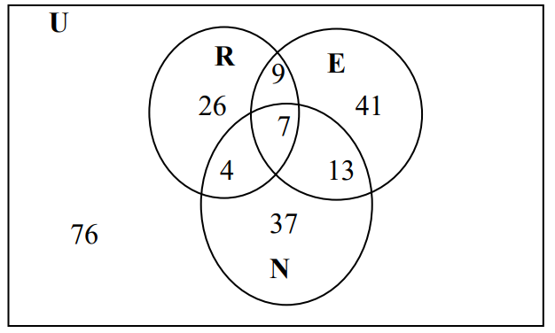  Use the diagram above to find the cardinality for each problem.  1. n(N)  2. n[(R ∩ E) ∪ N]  3. n(E′)  4. n(E\R)  5. n(U)  6. n(R ∪ E ∪ N)
Q27 | Illustrate each of the following by shading the Venn diagrams below.  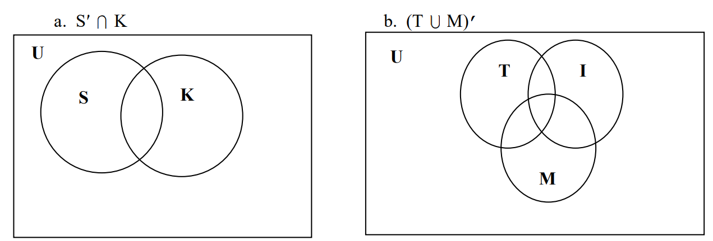
Q28 | Use the Venn diagram to work the following problem in three steps A′ ∪(B ∩C).  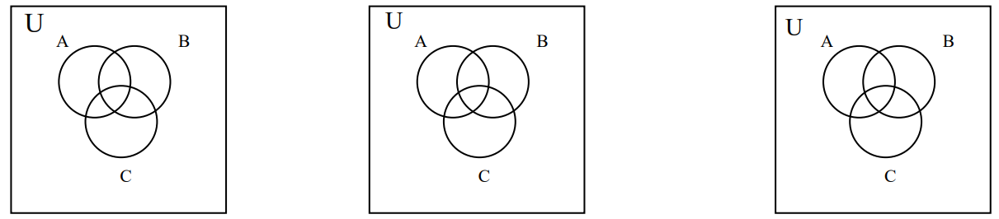
Q29 | A teacher surveyed her class of 43 students to find out how they prepared for their last test. She found that 24 students made flash cards, 14 studied their notes, and 27 completed the review assignment. Of the entire class of 43 students, 12 completed the review and made flash cards, 9 completed the review and studied their notes, and 7 made flash cards and studied their notes, while only 5 students completed all three of these tasks. The remaining students did not do any of these tasks. Represent this information in a Venn Diagram.
Q30 | A number of deer were surveyed about activities that they enjoy. The results are summarized in the Venn diagram below:  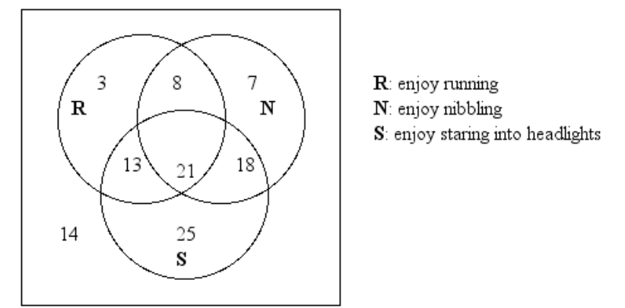  How many deer :  - Enjoy running or staring into headlights?  - Enjoy nibbling and running?  - Enjoy exactly one of these activities?  - Enjoy staring into headlights but not running?  - Enjoy nibbling?  - Don't enjoy any of the activities?  - Enjoy any two activities only?
Q31 | Draw a Venn diagram using 3 sets Q, T and P. None of these 3 sets are pairwise disjoint. Moreover, $P∩Q∩T≠ϕ$. How many disjoint regions are there? Indicate which regions fall under $(T∩Q)^{c}-P$.
Q32 | A survey of 1,200 people was conducted on three types of sports they enjoy: soccer, basketball, and baseball. Out of these, 670 enjoy soccer, 510 enjoy basketball, and 760 enjoy baseball. It was found that 320 people enjoy all three sports, while 45 people do not enjoy any of the three sports.  - How many people enjoy exactly two of these sports?  - How many people enjoy at least two of these sports?  - How many people enjoy exactly one of these sports?

